VIDEO, SOCIAL MEDIA, BULLETIN & PULPIT ANNOUNCEMENTS

Offering: Christian Vision and Hearing Services
(formerly Christian Services for the Blind & Hearing Impaired)
17 January 2026
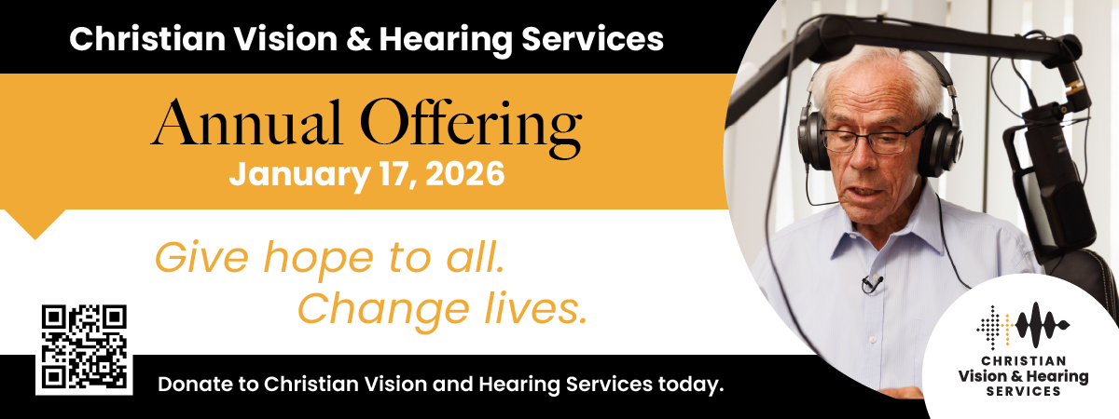

VIDEO (AUSTRALIA): The video for this offering can be downloaded from https://vimeo.com/1147197205?fl=pl&fe=vl

VIDEO (NEW ZEALAND): The video for this offering can be downloaded from https://vimeo.com/1147209247?share=copy&fl=sv&fe=ci

SOCIAL MEDIA: Social media tiles can be downloaded from https://stewardship.adventistchurch.com/offerings-aunz/

Dear Bulletin Secretary:

Your assistance with promoting this year’s Christian Vision and Hearing Services Offering is truly appreciated. This year the special collection takes place on January 17. Please insert the following announcements in your church bulletin for two Sabbaths, January 10 & 17.

BULLETIN ANNOUNCEMENTS

Please use the following announcement in your Church Bulletin on January 10
NEXT SABBATH’S OFFERING— Christian Vision and Hearing Services (January 17):
Christian Vision and Hearing Services, within Adventist Media, is a non-profit organisation that serves people who are blind, have low vision, cannot read standard print due to a physical condition, are Deaf, hard of hearing or deafblind in the South Pacific Division. It provides vital services and support to these communities free of charge, made possible by this annual church offering, donations and bequests. Please give generously to ensure the important work of Christian Vision and Hearing Services can continue and expand in 2026. You can also make an online, tax-deductible donation at any time via eGiving. Thank you.

Please use the following announcement in your Church Bulletin on January 17
Today’s Offering: Christian Vision and Hearing Services (also known as Christian Services for the Blind and Hearing Impaired [CSFBHI])
Christian Vision and Hearing Services, within Adventist Media, is a non-profit organisation that serves people who are blind, have low vision, cannot read standard print due to a physical condition, are Deaf, hard of hearing or deafblind in the South Pacific Division. It provides vital services and support to these communities free of charge, made possible by this annual church offering, donations and bequests.

Christian Vision and Hearing Services undertakes important advocacy and awareness building within Adventist churches to make them more accessible and inclusive, provides audio and braille resources for the blind, distributes large print materials to those with low vision, funds captioning and Auslan interpretation for the Deaf, and provides subsidies for assistive listening systems in churches for the hard of hearing. It also offers development grants to qualifying individuals or organisations to pursue specialised training in the area of accessibility, so they can make a beneficial contribution in the lives of those with deafness, vision or hearing loss, or physical limitations within the Adventist church.

Please give generously to today’s offering, to ensure the important work of Christian Vision and Hearing Services can continue and expand in 2026. You can also make an online, tax-deductible donation at any time via eGiving. Thank you for partnering with Christian Vision and Hearing Services to give hope to all and change lives.

PULPIT ANNOUNCEMENT. Please read the following pulpit appeal to the congregation before collecting the church service offering on Sabbath, January 17.

It’s now time to worship God through the returning of our tithe and giving of an offering. This week’s offering is for Christian Vision and Hearing Services.

Christian Vision and Hearing Services, within Adventist Media, is a non-profit organisation that serves people who are blind, have low vision, cannot read standard print due to a physical condition, are Deaf, hard of hearing or deafblind in the South Pacific Division. It provides vital services and support to these communities free of charge, made possible by this annual church offering, donations and bequests.

Please give generously to today’s offering, to ensure the important work of Christian Vision and Hearing Services can continue and expand in 2026. You can also make an online, tax-deductible donation at any time via eGiving. Thank you.

