**WORLD MISSION BUDGET OFFERING - July 12, 2025**



***Digital Strategy For Mission***

Dear Bulletin & Communications Leaders,

Your assistance with promoting the upcoming World Mission Budget Offering on July 12, 2025, is truly appreciated. Thank you! Please insert the following announcements into your church/Conference bulletins on the dates indicated. **Other promotional resources** for this offering, including social media tiles, are available for you to download at <https://stewardship.adventistchurch.com/offerings-aunz/>

**Banner Advertisement**

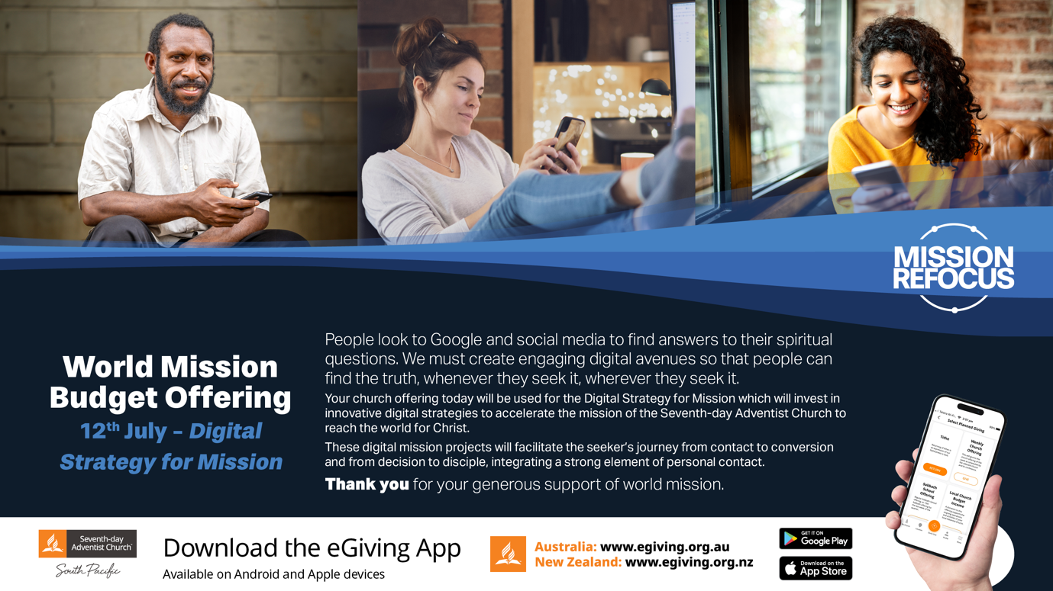(Please use in **all newsletters, bulletins & church Powerpoint slides until 12 July 2024**)

**July 5 Bulletins/Newsletters:**

**World Mission Budget Offering—July 12**: People look to Google and social media to find answers to their spiritual questions. We need to create engaging digital avenues so that people can find the truth, whenever they seek it, wherever they seek it.

Your church offering on 12 July will be used for the *Digital Strategy For Mission* which will invest in innovative digital strategies to accelerate the mission of the Seventh-day Adventist Church to reach the world for Christ. The selected digital mission projects will facilitate the seeker’s journey from contact to conversion and from decision to disciple, integrating a strong element of personal contact.

*Thank you* for your generous support of world mission.

**July 12 Bulletins/Newsletters:**

**It’s World Mission Budget Offering Day!** People look to Google and social media to find answers to their spiritual questions. We need to create engaging digital avenues so that people can find the truth, whenever they seek it, wherever they seek it.

Your church offering today will be used for the *Digital Strategy For Mission* which will invest in innovative digital strategies to accelerate the mission of the Seventh-day Adventist Church to reach the world for Christ. These digital mission projects will facilitate the seeker’s journey from contact to conversion and from decision to disciple, integrating a strong element of personal contact.

*Thank you* for your generous support of world mission.

**July 12 - Pulpit Announcement**

**WORLD MISSION BUDGET OFFERING - July 12, 2025**

The first disciples of Jesus made every sacrifice to use the latest technology of their day to proclaim the good news of salvation to all. They had the Roman roads and the written letter.

Our Adventist pioneers made every sacrifice to use the latest technology of their day to proclaim the good news of salvation to all. They had the shipping lanes and the printing press.

Today, we are called to make every sacrifice to proclaim the good news of salvation to "every nation, tribe, language, and people." (Revelation 14:6, NIV) Unlike those who have gone before us, we have many additional tools to advance the Gospel, including digital technology.

With almost 5 billion smartphones connected to the internet all around the world, including yours, it has never been easier to communicate.

However, actually being heard has never been more difficult. In this hyper-connected age, there is so much noise. People look to social media to find answers to their spiritual questions. We must create engaging digital avenues so people can find the truth, whenever they seek it, wherever they seek it.

The internet has eliminated borders, allowing the eternal gospel into the most difficult-to-reach people groups worldwide. The World Church, including each of us, must be committed to a comprehensive digital strategy for mission, reaching people online for Jesus.

And today, like those who have gone before us, you and I are called to make every sacrifice to proclaim the everlasting gospel "to those who dwell on the earth." Please give generously to today’s *Digital Strategy For Mission* offering to help fulfill God’s mission on today's digital highways.