**Mission to the Cities Offering 7 December 2024**

VIDEO, SOCIAL MEDIA, BULLETIN & PULPIT ANNOUNCEMENTS

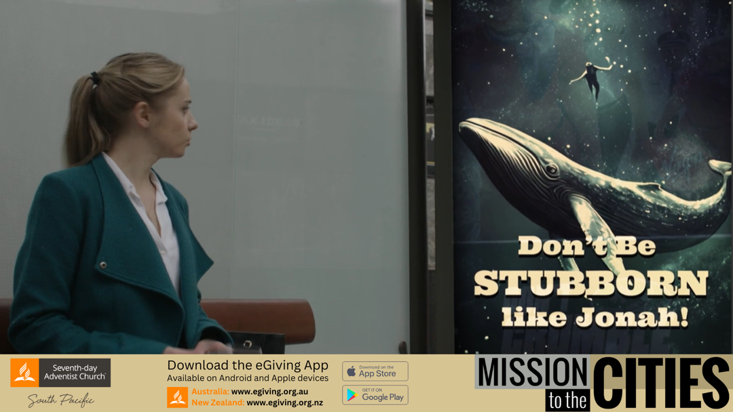

**AU VIDEO**: The video for this offering can be downloaded from <https://vimeo.com/1030567707>

**NZ VIDEO**: The video for this offering can be downloaded from <https://vimeo.com/1030565208>

**SOCIAL MEDIA**: Social media tiles can be downloaded from <https://stewardship.adventistchurch.com/offerings-aunz/>

**Dear Bulletin Secretary:**

Your assistance with promoting this year’s **Mission to the Cities Offering** is truly appreciated. Please insert the following announcements in your church bulletin for two Sabbaths, November 30 & December 7.

**BULLETIN ANNOUNCEMENTS**

*Please use the following announcement in your Church Bulletin on* ***November 30***

**NEXT SABBATH—Mission to the Cities Offering— December 7**:

It might surprise you to know that the most challenging mission field in the South Pacific Division is in our major cities, particularly amongst our post-Christian, majority people groups. God loves our cities. The Great Controversy on earth starts in the Garden of Eden but ends in a City - the New Jerusalem. God says to Jonah about that evil city Nineveh, "should I not have pity on that great city". When Ellen White wrote in 1910 that “the work in the cities is the essential work for this time”, New York city was smaller than Sydney is today. The work in our cities is still our essential work.

We want to thank you for your faithfulness in giving to the Mission to the Cities offering last year. That offering is being used in a number of projects including the Karla Bidjar, First Nations Church Plant in Perth, the Ponsonby Tent ministry in Auckland, the Food Farmacy in Newcastle, and Faith FM radio.

Please pray for our cities, pray for volunteers who will be willing to minister in our cities and pray that this Mission to the Cities offering will continue to help “the essential work of our time”.

*Thank you.*

*Please use the following announcement in your Church Bulletin on* ***December 7***

**Today’s offering is for Mission to the Cities**: It might surprise you to know that the most challenging mission field in the South Pacific Division is in our major cities, particularly amongst our post-Christian, majority people groups. God loves our cities. We want to thank you for your faithfulness in giving to the Mission to the Cities offering last year. That offering is being used in a number of projects including the Karla Bidjar, First Nations Church Plant in Perth, the Ponsonby Tent ministry in Auckland, the Food Farmacy in Newcastle, and Faith FM radio. Please pray for our cities, pray for volunteers who will be willing to minister in our cities and pray that this Mission to the Cities offering will continue to help “the essential work of our time”. *Thank you.*

**PULPIT ANNOUNCEMENT.**  Please read the following pulpit appeal to the congregation before collecting the church service offering on Sabbath, **December 7.**

It might surprise you to know that the most challenging mission field in the South Pacific Division is in our major cities, particularly amongst our post-Christian, majority people groups. God loves our cities. The Great Controversy on earth starts in the Garden of Eden but ends in a City - the New Jerusalem. God says to Jonah about that evil city Nineveh, "should I not have pity on that great city". When Ellen White wrote in 1910 that “the work in the cities is the essential work for this time”, New York city was smaller than Sydney is today. The work in our cities is still our essential work.

We want to thank you for your faithfulness in giving to the Mission to the Cities offering last year. That offering is being used in a number of projects including the Karla Bidjar, First Nations Church Plant in Perth, the Ponsonby Tent ministry in Auckland, the Food Farmacy in Newcastle, and Faith FM radio.

Please pray for our cities, pray for volunteers who will be willing to minister in our cities and pray that this Mission to the Cities offering will continue to help “the essential work of our time”.

*Thank you.*