Hope Channel Offering 12 April 2025
VIDEO, SOCIAL MEDIA, BULLETIN & PULPIT ANNOUNCEMENTS

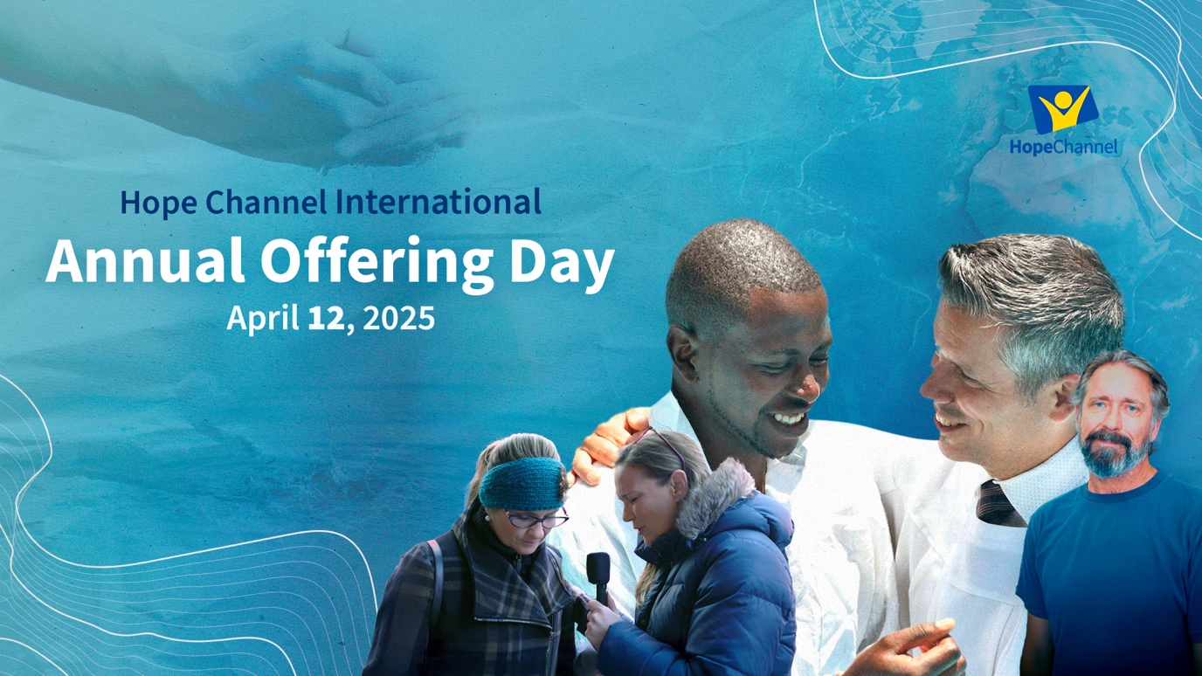

VIDEO: The video for this offering can be downloaded from INSERT VIMEO LINK HERE
SOCIAL MEDIA: Social media tiles can be downloaded from https://stewardship.adventistchurch.com/offerings-aunz/

Dear Bulletin Secretary:

Your assistance with promoting this year’s Hope Channel Offering is truly appreciated. Please insert the following announcements in your church bulletin for two Sabbaths, April 5 and 12.

BULLETIN ANNOUNCEMENTS

Please use the following announcement in your Church Bulletin on April 5
NEXT SABBATH—Hope Channel Offering— April 12:
Hope Channel International is using media to spread the gospel worldwide. With a network of over 80 media entities sharing content in more than 100 languages, it reaches millions through Bible studies, children’s programs, evangelistic campaigns, and more. Advanced dubbing technology and digital platforms break barriers, making messages of hope accessible in the most remote areas. Thank you for prayerfully preparing your offering for Hope Channel next Sabbath.

Please use the following announcement in your Church Bulletin on April 12
Today’s offering is for Hope Channel: Hope Channel International is using media to spread the gospel worldwide. With a network of over 80 media entities sharing content in more than 100 languages, it reaches millions through Bible studies, children’s programs, evangelistic campaigns, and more. Advanced dubbing technology and digital platforms break barriers, making messages of hope accessible in the most remote areas. Thank you for your offering today.

PULPIT ANNOUNCEMENT. Please read the following pulpit appeal to the congregation before collecting the church service offering on Sabbath, April 12.

Today's offering is for Hope Channel International, the Seventh-day Adventist Church’s global visual media ministry. With a network of over 80 media entities sharing content in more than 100 languages, Hope Channel is using media to share the gospel with people in every corner of the world.

Hope Channel International is reaching children through Bible-based animations, teaching young hearts about Jesus. Evangelistic campaigns like Hope for Africa have resulted in 194,000 baptisms, and cinema evangelism is making an impact through films like The Hopeful, which inspire deeper exploration of faith. Through social media, digital platforms, and television, Hope Channel is carrying the message of hope into homes in the most remote and restricted areas.
Plus, our advanced technology continues to empower media ministries around the world through Hope.Study, seekers can explore interactive Bible courses in multiple languages. Hope.Cloud provides cutting-edge tools that empower local media entities to expand their mission. Our advanced dubbing technology translates life-changing messages into dozens of languages, breaking down language barriers and reaching millions who might otherwise never hear the gospel.

We are told in Revelation 14:6 that the gospel will go to every nation, tribe, tongue, and people. Hope Channel is doing just that. Thank you for your gift today. Your generosity ensures that millions more will have the opportunity to hear about Jesus.

